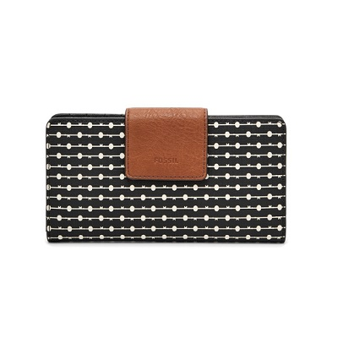

Emma RFID Tab Clutch

PRODUCT DETAILS

**Silhouette: Tab Clutch**

**Exterior Material: PVC/Polyurethane Trim**

**Interior Details: 12 Credit Card Slots, 1 ID Window and 4 Bill Compartments**

**Measurements: 7"L x 0.88"W x 3.5"H**

**Warranty: 1 Year Limited**